Wilkinson power divider development
Xinhang Xu
8/26/2026
- Calculate the impendence on each trace through Wilkinson101_Rev1.3.xls
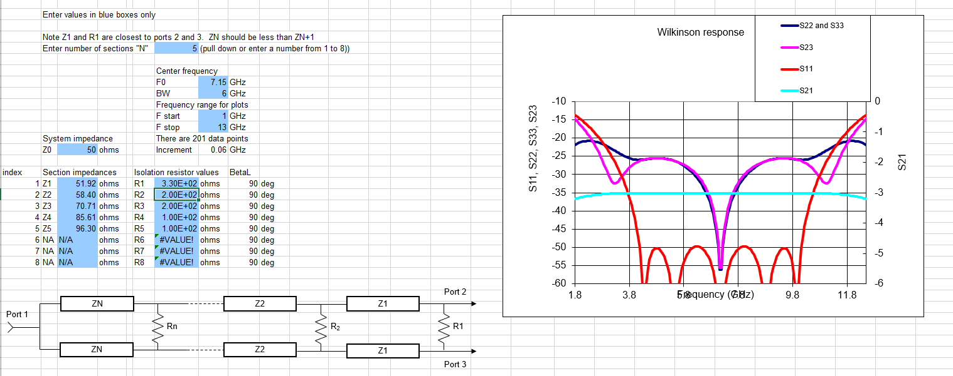

- Calculate the width of the microstrip for specifical impedance.

1. There are two different dielectric constant value for calculating the impedance of microstrip:
(a). Data from R04350B datasheet, which is about 3.73 at 7GHz
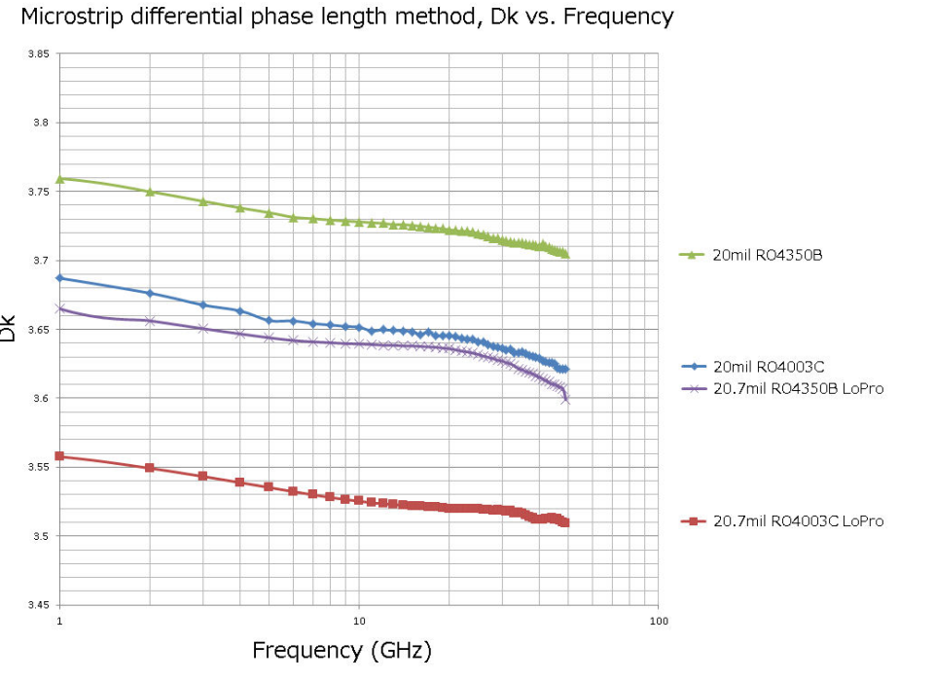
Figure 1. Dielectric constant
(b). Data from CST software, which is 3.66 , as shown in Figure 2. Which value should I filled in
the microstrip impedance calculation?
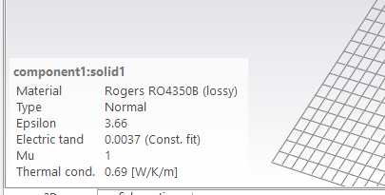
Figure 2. Dielectric constant from CST

Claude answer:
Use 3.66 — the value already loaded in your CST material (component1:solid1), not the 3.75 you're reading off the datasheet plot.
Here's why these two numbers exist and disagree:
The datasheet actually lists more than one Dk, and they're not interchangeable:
- Process Dk = 3.48 ± 0.05 — measured by clamped-stripline resonator at 10 GHz. This is a QC/process-control number, and the clamped-stripline method can potentially lower the actual dielectric constant due to the presence of an air gap. Jlcpcb
- Design Dk = 3.66 — measured 8 to 40 GHz by the differential phase length method, and this is the number Rogers explicitly intends for circuit/impedance design. MCL PCB
The 3.75 you're seeing is most likely from the datasheet's Dk-vs-frequency dispersion curve (which is thickness-dependent and drawn from a different characterization set), not the tabulated design value. It's not meant to be plugged directly into a simple impedance calculator.
For a field solver / impedance calculation, always use the design Dk (3.66): the 3.48 figure is the process Dk measured via clamped stripline resonator, and it is not the value you should plug into your impedance solver — Rogers recommends design Dk of 3.66 for impedance modeling on microstrip and stripline. Engineers who plug the lower process value into a solver systematically get traces too narrow and impedance too low: using 3.48 in an impedance calculator gives traces that are too narrow. MediumPCBSync
On frequency :RO4350B's Dk is intentionally very flat across the microwave band — RO4350B provides a stable Dk of 3.48 from 500 MHz to over 40 GHz with minimal variation versus frequency (the corresponding design-Dk figure being 3.66 over the same range). So you don't need to chase a frequency-corrected value for 7.1 GHz — 3.66 at 2 GHz and 3.66 at 7.1 GHz are the same design value; dispersion in this material over that span is small enough to ignore for a thin-microstrip Z₀ calculation. RayPCB
So: set eps_r = 3.66 in the Impedance Calculation dialog — it matches what CST's material model is already using, so your 3D build and your quick hand-calc will stay self-consistent.

  - Process Dk = 3.48 ± 0.05 (10 GHz, clamped-stripline, QC test)
  - Design Dk = 3.66 (differential phase-length method, 8–40 GHz band) — (cite index="3-1">measured across 8 to 40 GHz by the Differential Phase Length Method</cite>, i.e. it's already the value Rogers derived to be representative across that whole microwave range, not a single-point 10 GHz number.

2. There are two different tool for calculating the impedance of microstrip: KiCAD and CST
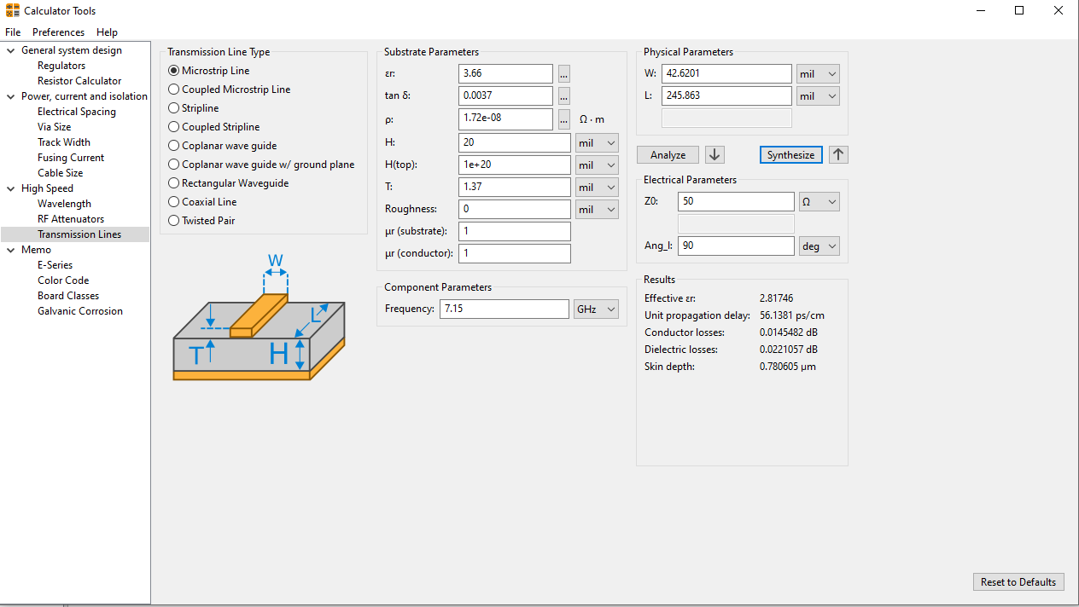
Figure 3. Calculator tools in KiCAD for Z0 =50 ohm
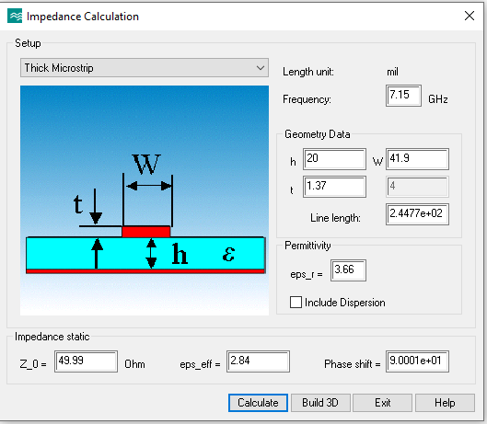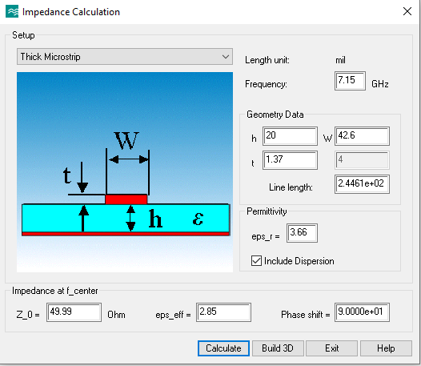
Figure 4. Impedance calculation tool from CST, we should consider the structure dispersion with Include dispersion selected.
Since two tools show two different L required for 90 phase degree, I prefer to use results from CST module.
Table 1. Trace width and length on each stage (5 stage)
Z0(90 degree) | W(mil) | L(mil)
51.92 | 39.92 | 245.22
58.40 | 32.3 | 247.15
70.71 | 21.85 | 250.50
85.61 | 13.88 | 253.7
96.30 | 9.89 | 255.54
50 | 42.6 | **

Table 2. Trace width and length for 4 stage
Z0(90 degree) | W(mil) | L(mil)
53.49 | 37.9 | 245.7
63.31 | 27.6 | 248.53
78.98 | 16.98 | 252.4
93.48 | 10.83 | 255.1
50 | 42.6 | **

- Draw the Wilkinson power divider through KiCAD footprint (refer to link)

(KiCad library Resistor_SMD, footprint R_0402_1005Metric) has pads with centers that are 20.08 mil apart with dimensions of 21.26 mil and 25.2 mil. The gap between the two pads is 40.16 – 21.26 = 18.9 mil, which needs to be maintained (no metal between y= -9.45 and +9.45 mil)
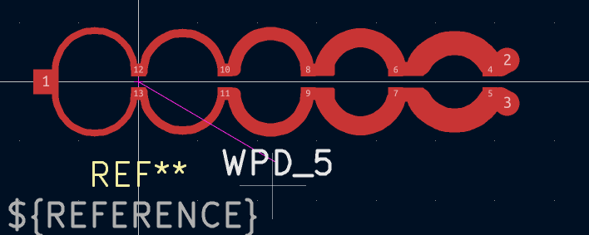
Figure 5. WPD footprint in KICAD

- Export the gerber file to CST for simulation (list detail steps)

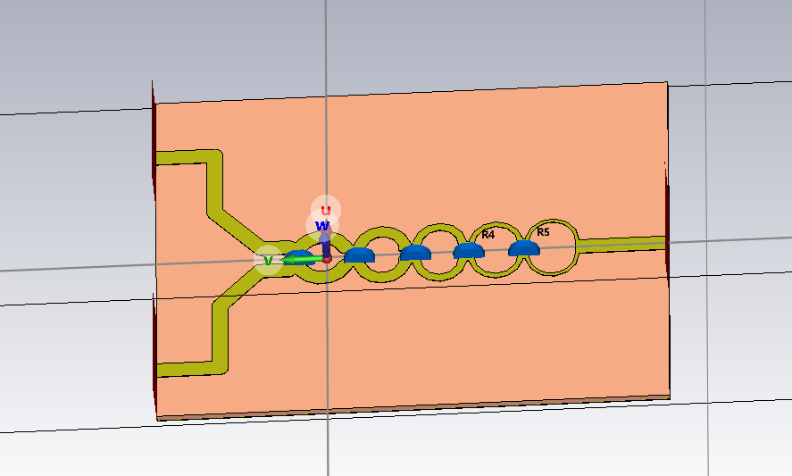
Figure 6.3D figure of WPD with 20 mil RO4350B boards

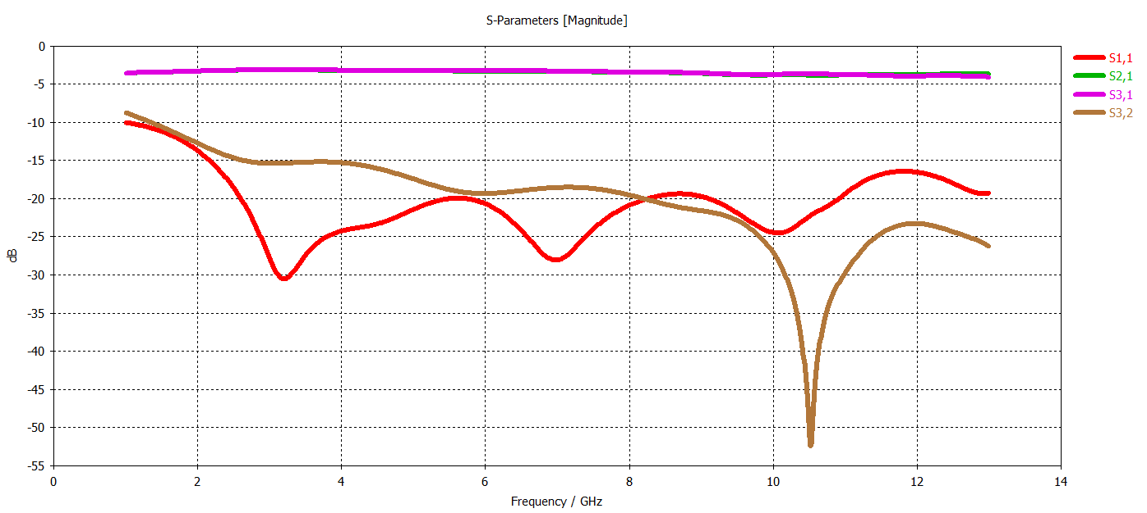
Figure 7.The S parameters of WPD, the resistors from output port to the input port are 100 ,100,200,200,330 ohm respectively.
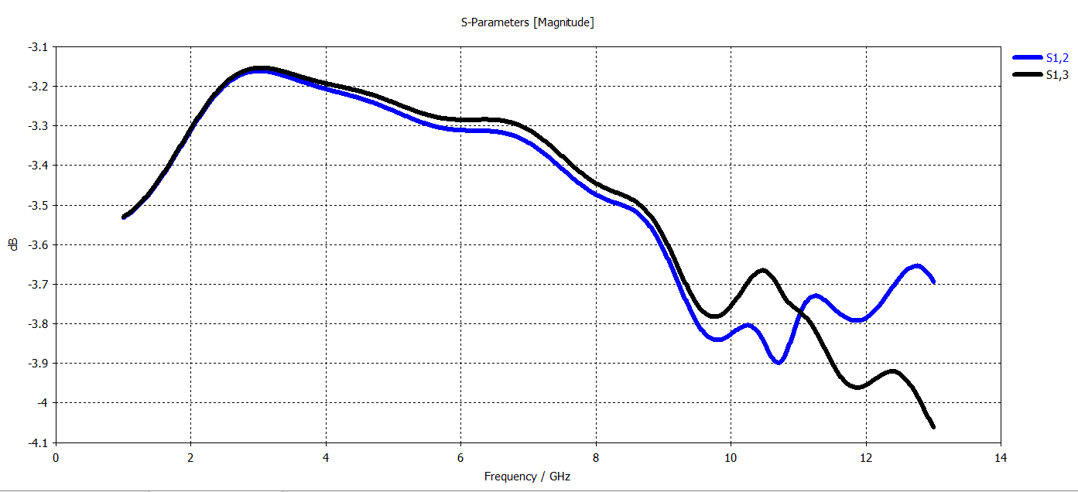
Figure 8.The S parameters of WPD, the resistors from output port to the input port are 100 ,100,200,200,330 ohm respectively.
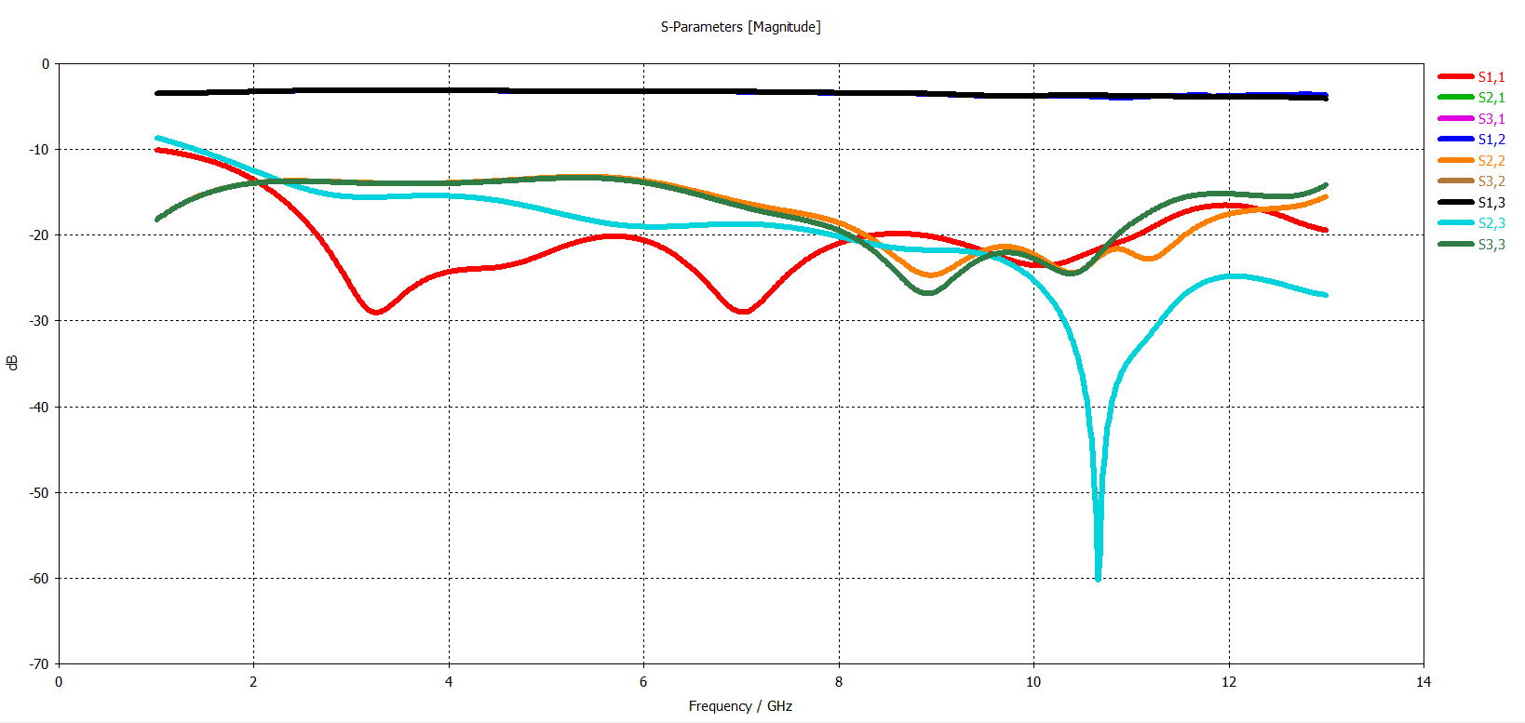
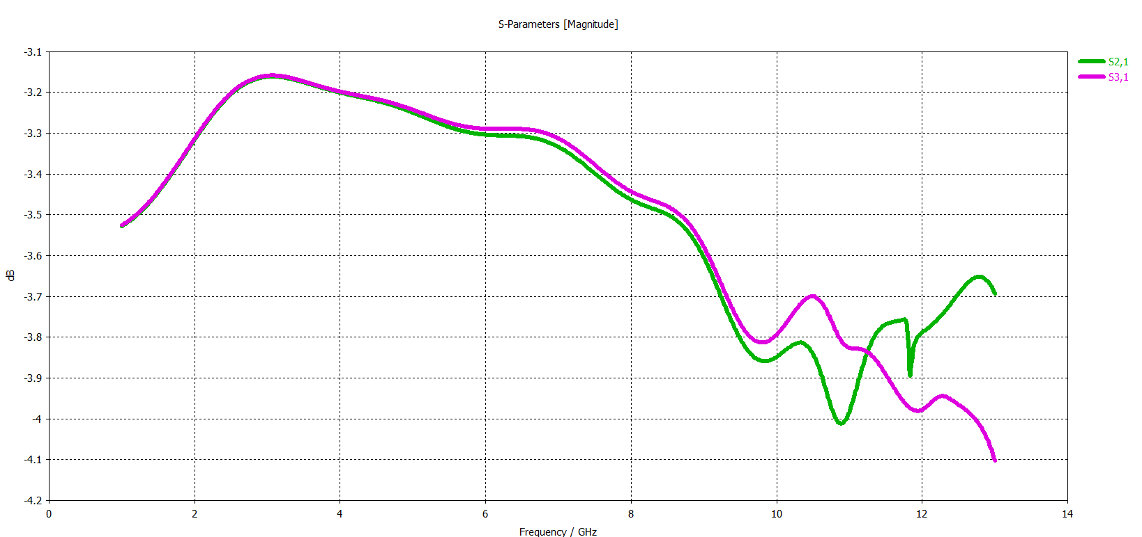
Figure 9.The S parameters of WPD, the resistors from output port to the input port are 100 ,100,200,200,200 ohm respectively.

# -*- coding: utf-8 -*-
"""
Created on Tue Aug 25 12:28:48 2026

@author: mmwave
"""
get_ipython().run_line_magic('reset', '-sf') # noqa
import numpy as np

# %% trace1;
Width_T0 = 42.6;
Width_T1 = 10.5549;
L1 = 255.54;
W_pad_x = 25.2;
W_pad_y = 21.26;
yc_pad= 20.08;
Y1_right = 20.08
X1_right = -1/2*W_pad_x+ 1/2*Width_T1

L1_m = L1-2*Y1_right- np.abs(X1_right)
R1_m =L1_m/np.pi;
X1_left = -2*R1_m+X1_right
Y1_left = Y1_right
X1_C = X1_right - R1_m
Y1_C = Y1_left
X_in = X1_left - Width_T0/2+Width_T1/2
# print(f"X1_left={X1_left:.4f} mil,Y1_left={Y1_left:.4f} mil" )
# print(f"X1_right={X1_right:.4f} mil,Y1_right={Y1_right:.4f} mil" )
# print(f"X1_C={X1_C:.4f} mil,Y1_C={Y1_C:.4f} mil" )

# trace2;
Width_T2 = 13.88;
L2 = 253.7;
theta_trace_2 =3*np.pi/3
theta_trace_2_degree = theta_trace_2*180/np.pi
X2_left=Width_T1/2+Width_T2/2+3.5+X1_right
Y2_left = yc_pad-W_pad_y/2+Width_T2/2
Y2_right= Y2_left

L2_m = L2 - 2 * Y2_right - X2_left - (-Width_T2 / 2 + W_pad_x / 2)
R2_m = L2_m/theta_trace_2;
X2_right= X2_left + 2*R2_m*np.sin(1/2*theta_trace_2)
X2_C= X2_left + R2_m*np.sin(1/2*theta_trace_2)
Y2_C= Y2_left -R2_m*np.cos(1/2*theta_trace_2)
X_2R = X2_right-Width_T2/2+W_pad_x/2

# print(f"X2_left={X2_left:.4f} mil,Y2_left={Y2_left:.4f} mil" )
# print(f"X2_right={X2_right:.4f} mil,Y2_right={Y2_right:.4f} mil" )
# print(f"X2_C={X2_C:.4f} mil,Y2_C={Y2_C:.4f} mil" )
# print(f"incident angle = {theta_trace_2_degree:.5f} degree")

# %%trace3;
Width_T3 = 21.85;
L3 = 250.5;
theta_trace_3 =3*np.pi/3
theta_trace_3_degree = theta_trace_3*180/np.pi
X3_left=Width_T2/2+Width_T3/2+3.5+X2_right
Y3_left = yc_pad-W_pad_y/2+Width_T3/2
Y3_right= Y3_left

L3_m = L3 - 2 * Y3_right - (X3_left-X_2R) - (-Width_T3 / 2 + W_pad_x / 2)
R3_m = L3_m/theta_trace_3;
X3_right= X3_left + 2*R3_m*np.sin(1/2*theta_trace_3)
X3_C= X3_left + R3_m*np.sin(1/2*theta_trace_3)
Y3_C= Y3_left -R3_m*np.cos(1/2*theta_trace_3)
X_3R = X3_right-Width_T3/2+W_pad_x/2

# print(f"X3_left={X3_left:.4f} mil,Y3_left={Y3_left:.4f} mil" )
# print(f"X3_right={X3_right:.4f} mil,Y3_right={Y3_right:.4f} mil" )
# print(f"X3_C={X3_C:.4f} mil,Y3_C={Y3_C:.4f} mil" )
# print(f"X_3R = {X_3R:.5f} mil")
# print(f"incident angle = {theta_trace_3_degree:.5f} degree")

# %% trace4;
Width_T4 = 32.3;
L4 = 247.15;
theta_trace_4 =4*np.pi/5
theta_trace_4_degree = theta_trace_4*180/np.pi
X4_left=Width_T3/2+Width_T4/2+3.5+X3_right
Y4_left = yc_pad+W_pad_y/2
Y4_right= Y4_left

L4_m = L4 - 2 * Y4_right - (X4_left-X_3R)
R4_m = L4_m/theta_trace_4;
X4_right= X4_left + 2*R4_m*np.sin(1/2*theta_trace_4)
X4_C= X4_left + R4_m*np.sin(1/2*theta_trace_4)
Y4_C= Y4_left -R4_m*np.cos(1/2*theta_trace_4)
X_4R = X4_right

# print(f"X4_left={X4_left:.4f} mil,Y4_left={Y4_left:.4f} mil" )
# print(f"X4_right={X4_right:.4f} mil,Y4_right={Y4_right:.4f} mil" )
# print(f"X4_C={X4_C:.4f} mil,Y4_C={Y4_C:.4f} mil" )
# print(f"X_4R = {X_4R:.5f} mil")
# print(f"incident angle = {theta_trace_4_degree:.5f} degree")

# %% trace5;
Width_T5 = 39.92
L5 = 245.22
theta_trace_5 =2*np.pi/3
theta_trace_5_degree = theta_trace_5*180/np.pi
X5_left=Width_T4/2+Width_T5/2+X4_right
Y5_left = yc_pad+W_pad_y/2
Y5_right= Y5_left

L5_m = L5 - 2 * Y5_right - (X5_left-X_4R)
R5_m = L5_m/theta_trace_5;
X5_right= X5_left + 2*R5_m*np.sin(1/2*theta_trace_5)
X5_C= X5_left + R5_m*np.sin(1/2*theta_trace_5)
Y5_C= Y5_left -R5_m*np.cos(1/2*theta_trace_5)
X_5R = X5_right

print(f"X5_left={X5_left:.4f} mil,Y5_left={Y5_left:.4f} mil" )
print(f"X5_right={X5_right:.4f} mil,Y5_right={Y5_right:.4f} mil" )
print(f"X5_C={X5_C:.4f} mil,Y5_C={Y5_C:.4f} mil" )
print(f"X_5R = {X_5R:.5f} mil")
print(f"incident angle = {theta_trace_5_degree:.5f} degree")

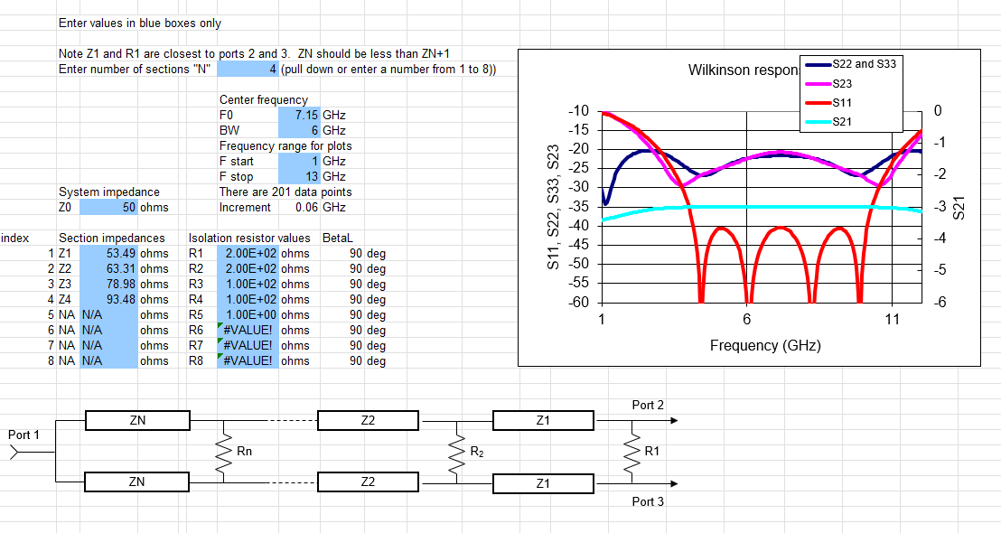
Figure 10. 4 stage wpd

